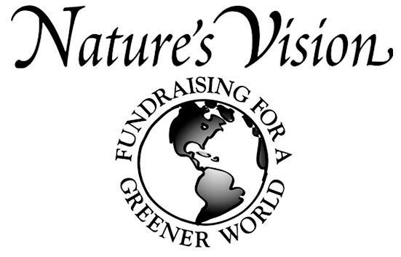
CCLA-PTO Fundraiser/募捐活动
Dear Parents:
CCLA-PTO is sponsoring our fundraiser of the year to raise important funds to benefit our children and community. Nature’s Vision was selected for their wide variety of top quality environmentally themed products and the fact that 40% of the sales will be going directly to CCLA-PTO benefiting our children and our school. Please help us make our sale a success by showing the catalog to your family, friends and co-workers.

We are again offering a direct donations option to you to support our school. If you are unable to sell or are not interested in the items, please consider giving a direction donation in any amount you feel fit to the CCLA-PTO by Sunday, December 7th. For direct donations, please make checks payable to CCLA-PTO and put in an envelope marked "PTO Fundraiser Direct Donation." Please drop off to your teacher by Sunday, December 7th.
CCLA-PTO今年再次主办一个募捐活动，筹集资金有益于我们的儿童和学校的活动。我们选择了Nature's Vision 不仅是因为他们的高品质环保为主题的产品, 而且40%的销售金额直接受益CCLA-PTO。请帮助我们的募捐活动的成功， 向你们的家人，朋友和同事推销。若你无法出售或对出售商品没有兴趣，请考虑直接捐款，你觉得合适的任何金额我们都欢迎。若直接捐款，支票请写给“CCLA-PTO”，并请在信封上注明“PTO募捐活动直接捐款”，在12月7日（星期日）那天交给你们的老师。

SALE DATES发售日期:
Sale starts today and order forms and money are due on Sunday, December 7th, 2014. 从今天起销售,填好的订单表格和金额于2014年12月7日收集

IMPORTANT FUNDRAISING INFORMATION重要的募捐信息:
1. Please make all checks or money orders payable to CCLA-PTO and remember to collect the money when taking your orders. 请将所有支票或汇票支付给CCLA-PTO, 在您收订单时，请记住收钱。
2. Double check to make sure your order form is complete and accurate. 请仔细检查您的订单，以确保您的订单完整和准确。
3. You will be notified of the product arrival day and pickup time. The orders should be available for pick up before the holidays. 货品到达后，我们会再通知在学校的领货地点。货品会在节日前到达。

AWARDS奖项:
1. All participants earn special prizes based on the number of items they sell. 所有参加者根据他们卖出项目数量都能获得特别的奖品。
2. You will receive ONE FREE ITEM of your choice from this catalog for every 12 items you sell. 您每卖出12件货品, 就会收到1件目录中自选的免费货品。
3. Please remember to order your free items and include your size for T-Shirts. 请自己记住订您的免费货品，包括T恤衫的大小和款式。

FUNDRAISING QUESTIONS募捐质询:
If you have any questions, please email Zimei Huang at emailmei2001@yahoo.com. 如果您有任何问题，请发电子邮件给：emailmei2001@yahoo.com

THANK YOU FOR YOUR SUPPORT AND PARTICIPATION!!!
PLEASE REMEMBER: SAFETY COMES FIRST. NEVER SELL TO STRANGERS!!! 感谢大家的支持和参与！
请记住：安全第一。不要出售给陌生人!!!

